Fast start

In this short description, all import phases of surface x-ray data modeling with WinRod are presented. This program was created to make the surface x-ray data analysis simpler and faster. Most of the ideas are directly taken form ROD program originally written by Prof. Elias Vlieg. WinRod uses modified calculation engine from ROD.

- Installation

To install WinRod for regular use four thinks are necessary:

-System Windows 7, 8 or 8.1
-DirectX 9.0c Jun 2010 redistributables directx_Jun2010_redist.exe (95MB)

-Visual Studio 2013 redistributables for 32/64 bit system version system
vcredist_x86.exe (6MB) or vcredist_x64.exe (7MB)
-WinRod installation package 32/64 bit version
WinRod_x32_install.zip (8MB) or WinRod_install_x64_AVXt.zip (9MB)

The vcredist_x86.exe and Visual Studio 2013 redistributables are self-extracting archives from Microsoft the WinRod.zip installation file have to be uncompressed prior to installation. To begin installation start setup.exe file. The installation program will guide you through the rest of the installation process.

To install WinRod for development:

-System Windows 7, 8 or 8.1
-DirectX 9.0c Jun 2010 SDK
-Visual Studio 2013 express (only 32 bit) or ultimate (32/64/bit)
-WinRod project(170MB)

Visual Studio has to be correctly set. All directories for project has to be set in project properties, especially DirectX patches. It can be necessary to add ATL libraries for express edition of Visual Studio 2013. The project file can be started for WinRod.sln file.
In this case WinRod can be compiled for older processors without AVX (advanced Instruction Set) and for new processors which supports AVX.

- Requirements

Windows system 7, 8 or 8.1. A new generation of processors (with multiple cores) is recommended. Processors with AVX instructions double the speed of calculations but for this a special compilation setting is required. Intel processors are usually better in such calculations. For directX 9.0c a new graphics card is recommended.

- First look.

  - overall view
WinRod is composed on several independent windows which can be freely arrangement on the screen. The windows positions are remembered when program is exited with File-> Exit. WinRod can works on system with multiple monitors.

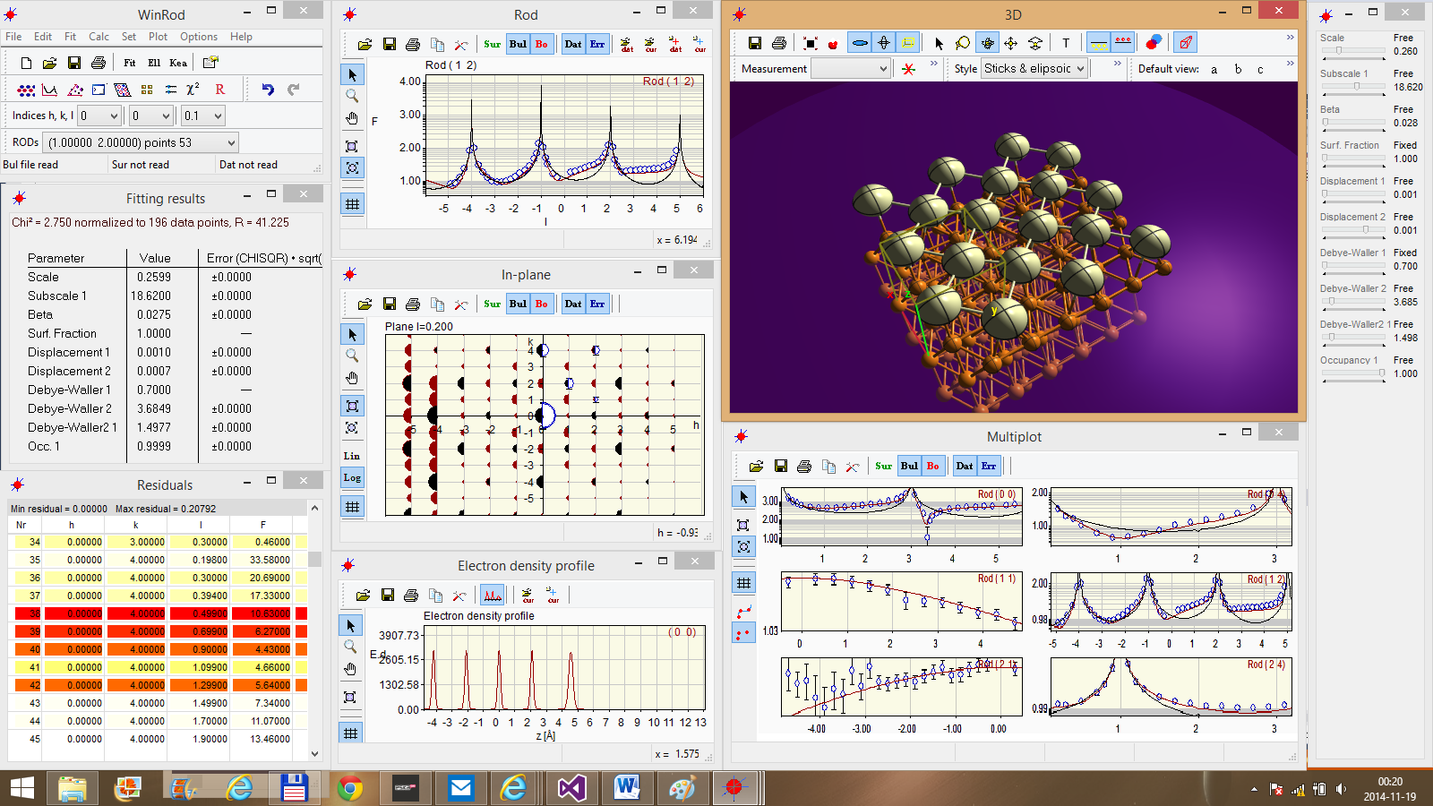

----------------------------------------------- File menu ----------------------------------------------------

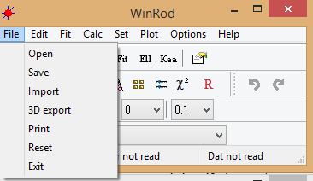

File ->Open – the standard windows dialog box for reading all WinRod files like: sur, fit, bul, dat, mac, par, fat and new WinRod related mft for organic molecules. By default all ROD and WinRod files are shown in the window below. It is possible to read *.mac file with the project in this case *.mac file can include all settings and files which have to be read.

Example AgSb.mac file to fast start the project.

set
indexh 1
indexk 1
indexl 0.2

read fat elements.fat
read fit agsb.fit
read bul ag111.bul
read dat agsb.dat
read par agsb.par

set domain
ndomain 1
matrix 1 1.0000 0.0000 0.0000 1.0000

!Go to multiplot
Multiplot 9 2 250
Multiplot_select 0 yes
Multiplot_select 1 yes
Multiplot_select 2 no
Multiplot_select 3 no
Multiplot_select 4 yes
Multiplot_select 5 yes
Multiplot_select 6 no
Multiplot_select 7 no
Multiplot_select 8 no

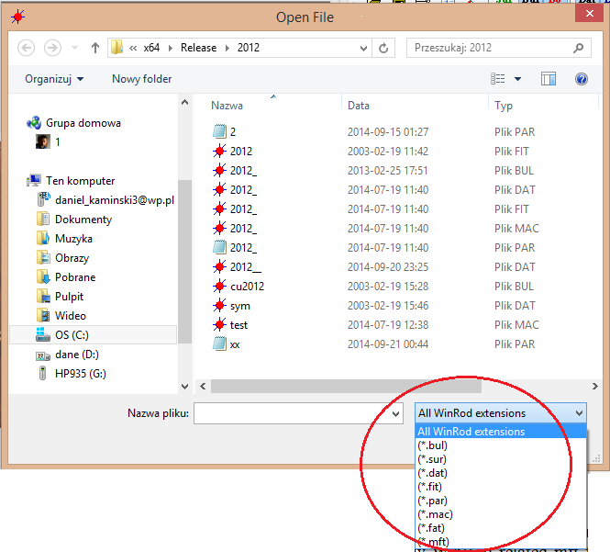

All files of ROD or WinRod can be also associated with WinRod directly from Windows system. In this case double click will open selected file with WinRod.

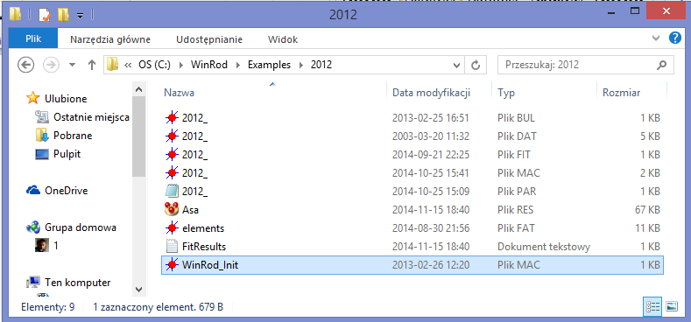

File ->Save – open dialog window for saving

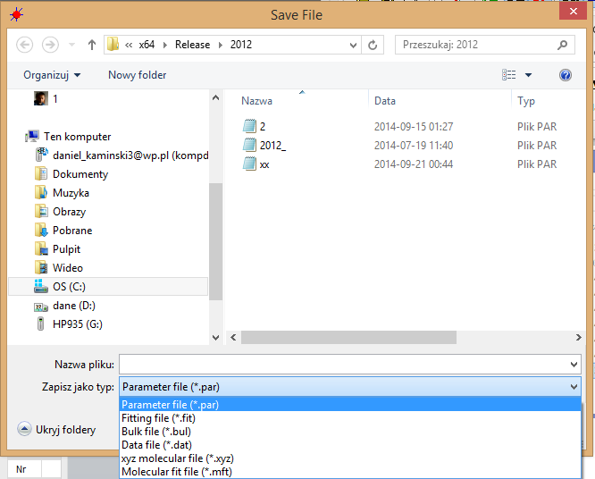

With save all files can be saved after modification. Additionally the molecular file *.xyz can be generated from the project.

File ->Import – a new option to import organic molecular files

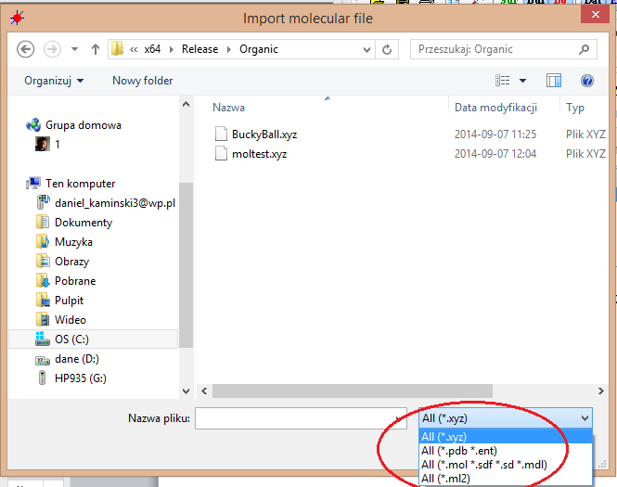

In this case organic molecule is transformed to bulk unit cell if such one was read or stays in 1, 1, 1, 90, 90, 90 unit cell. From this *.mft flie can be saved directly. *.mft file can hold data for more than one organic molecule; see the example on the end of this document.

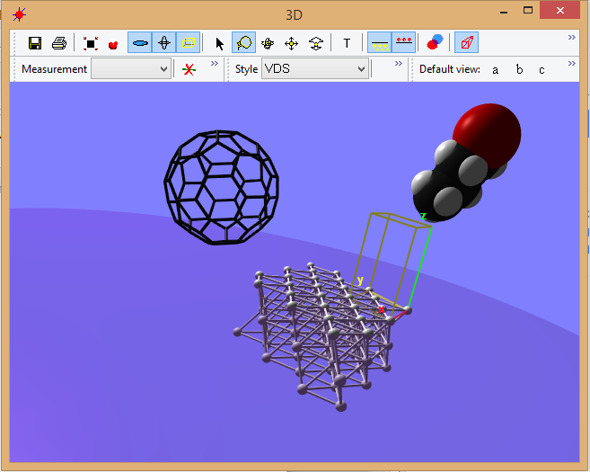
*.mft file example:

Header
molecule #0 fulerene
1.0000 1 2.0000 2 3.0000 3 1 1 1 1 1 1
C 1.4214 -2.9041 -1.6012 0.0000 0.0000
C 2.6214 -2.2723 -1.3448 0.0000 0.0000
C 2.9405 -1.1136 -2.0037 0.0000 0.0000
C 2.0620 -0.5786 -2.9240 0.0000 0.0000
C 0.8703 -1.2060 -3.1787 0.0000 0.0000
C 0.5490 -2.3728 -2.5149 0.0000 0.0000
C 1.8440 0.7740 -2.9560 0.0000 0.0000
C 0.5176 0.9824 -3.2302 0.0000 0.0000
C -0.0841 -0.2410 -3.3682 0.0000 0.0000
C 2.5018 1.6018 -2.0686 0.0000 0.0000
C 1.8311 2.6342 -1.4641 0.0000 0.0000
C 0.4957 2.8426 -1.7422 0.0000 0.0000
C -0.1587 2.0197 -2.6202 0.0000 0.0000
C 3.3741 1.0706 -1.1549 0.0000 0.0000
C 3.5940 -0.2918 -1.1233 0.0000 0.0000
C -1.4323 1.8280 -2.1544 0.0000 0.0000
C -2.0399 0.5967 -2.2915 0.0000 0.0000
C -1.3663 -0.4344 -2.8951 0.0000 0.0000
C -1.6851 -1.5930 -2.2362 0.0000 0.0000
C -0.7241 -2.5652 -2.0459 0.0000 0.0000
C 0.6876 -3.4251 -0.5677 0.0000 0.0000
C -0.6382 -3.2152 -0.8426 0.0000 0.0000
C -2.5561 -1.2797 -1.2241 0.0000 0.0000
C -2.7732 0.0718 -1.2610 0.0000 0.0000
C -1.5704 2.5375 -0.9864 0.0000 0.0000
C -0.3754 3.1662 -0.7316 0.0000 0.0000
C 2.2914 2.7383 -0.1786 0.0000 0.0000
C 3.2440 1.7740 0.0155 0.0000 0.0000
C 3.6782 -0.9425 0.0797 0.0000 0.0000
C 3.0776 -2.1664 -0.0569 0.0000 0.0000
C 2.3381 -2.6907 0.9841 0.0000 0.0000
C 1.1466 -3.3181 0.7297 0.0000 0.0000
C -1.5128 -2.8987 0.1774 0.0000 0.0000
C -2.4681 -1.9361 -0.0135 0.0000 0.0000
C -2.9175 0.7825 -0.0813 0.0000 0.0000
C -2.3304 2.0179 0.0484 0.0000 0.0000
C 0.0921 3.2921 0.5662 0.0000 0.0000
C 1.4187 3.0653 0.8457 0.0000 0.0000
C 3.3301 1.1167 1.2258 0.0000 0.0000
C 3.5446 -0.2356 1.2579 0.0000 0.0000
C 2.8134 -0.7580 2.2915 0.0000 0.0000
C 2.2070 -1.9902 2.1559 0.0000 0.0000
C 0.2776 -3.0065 1.7441 0.0000 0.0000
C -1.0574 -2.7963 1.4651 0.0000 0.0000
C -2.6093 -1.2377 1.1602 0.0000 0.0000
C -2.8496 0.1260 1.1245 0.0000 0.0000
C -1.8843 2.1353 1.3093 0.0000 0.0000
C -0.6386 2.7966 1.5777 0.0000 0.0000
C 1.5171 2.4261 2.0580 0.0000 0.0000
C 2.4667 1.4354 2.2453 0.0000 0.0000
C 2.1471 0.2734 2.9054 0.0000 0.0000
C 0.9349 -2.1871 2.6227 0.0000 0.0000
C -1.7352 -1.7702 2.0769 0.0000 0.0000
C -2.2214 0.9258 2.0009 0.0000 0.0000
C 0.2748 2.2372 2.5305 0.0000 0.0000
C -0.0594 1.0259 3.2252 0.0000 0.0000
C 0.8680 0.0703 3.3967 0.0000 0.0000
C 0.2570 -1.1516 3.2440 0.0000 0.0000
C -1.0775 -0.9545 2.9827 0.0000 0.0000
C -1.3043 0.3686 2.9546 0.0000 0.0000
molecule #1 buthanol
-3.0000 4 -4.0000 5 0.1039 6 2 2 2 2 2 2
C -0.9574 -1.7523 0.1039 0.0000 0.0000
C -1.9436 -0.5778 0.1556 0.0000 0.0000
C -1.2582 0.7527 -0.1917 0.0000 0.0000
C -2.2416 1.9274 -0.1433 0.0000 0.0000
O -1.5612 3.1092 -0.4766 0.0000 0.0000
H -1.4635 -2.7122 0.3574 0.0000 0.0000
H -0.1226 -1.6084 0.8280 0.0000 0.0000
H -0.5156 -1.8604 -0.9134 0.0000 0.0000
H -2.3907 -0.5144 1.1766 0.0000 0.0000
H -2.7783 -0.7664 -0.5610 0.0000 0.0000
H -0.8134 0.6868 -1.2132 0.0000 0.0000
H -0.4239 0.9407 0.5255 0.0000 0.0000
H -2.6736 2.0716 0.8741 0.0000 0.0000
H -3.0624 1.8083 -0.8870 0.0000 0.0000
H -0.9595 3.2938 0.2245 0.0000 0.0000

The example *.mft file with two organic molecules fullerene and butanol. On the right the 3D scene from the this mft file.

File ->3D export – allows to export 3D scene to the following graphics formats:
bmp, jpg, tga, png, dds, dib with standard Save Windows dialog box.

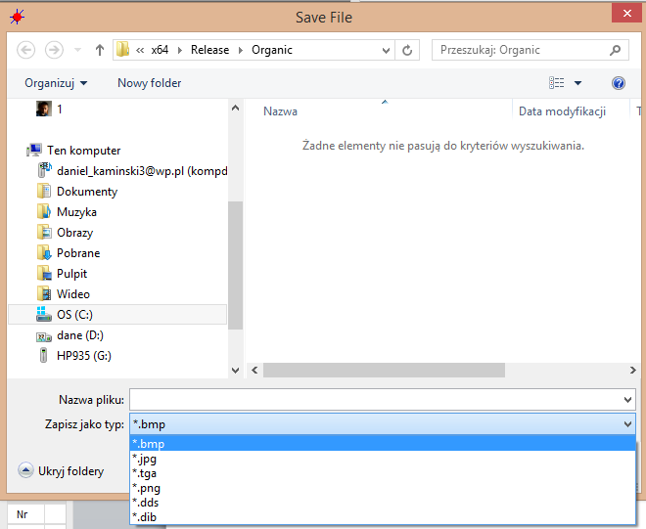

File ->Print – prints the 3D scene

File ->Reset – reset all project settings. After this a new WinRod file with different lattice settings can be read.

---------------------------------------------- Menu Edit ----------------------------------------------------

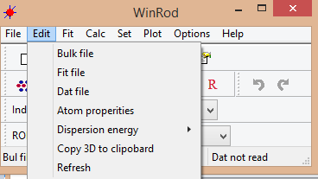

Edit-> bulk file – bulk file edit window.
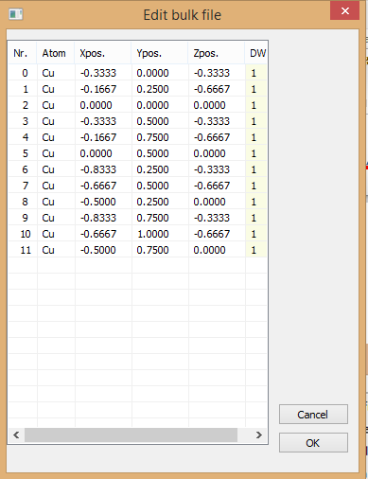

Edit –> Fit file – fit file editor, in case of *.mft files it looks different
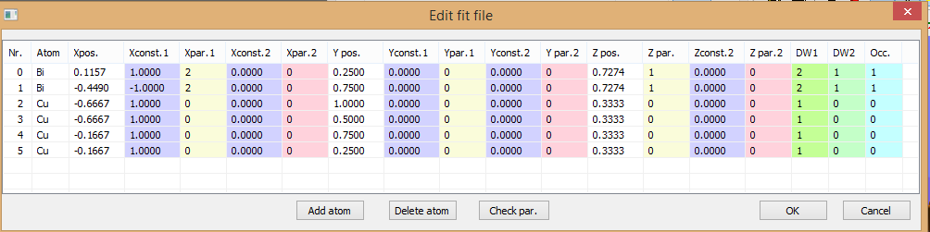

In case of *.mft file for organic molecules:
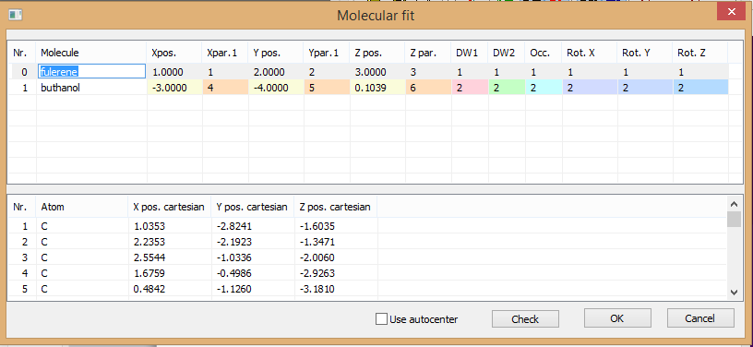
In all edit windows any changes will be immediately apply after pressing OK button.
Edit->data file – in this dialog box Error increase increases error bars near Bragg reflections according to Elias algorithm. All fields can be edited and the effect will be directly seen in the project after pressing OK button.

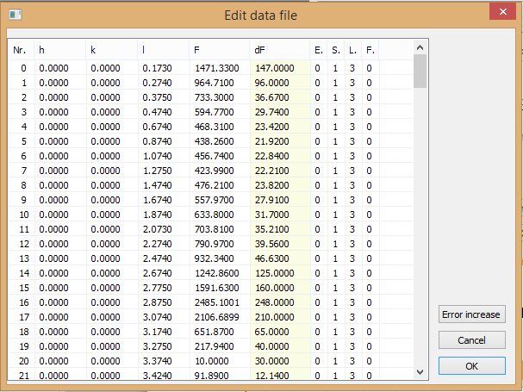

Edit-> Atom properties – It is for 3D settings atom radius and color. Not all values are set correctly at the moment what can leads to extra bonds in 3D scene. These distance van der Waals values are used only for 3D scene construction.

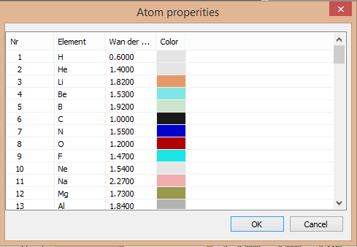
Edit-> Dispersion energy - > edit F1 – edit f’ coefficients for all project atoms

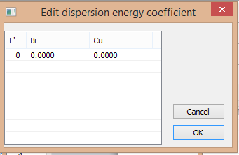

Edit-> Dispersion energy - > edit F2 – the same for f”

Edit->Dispersion energy -> calculate coefficients – this dialog box help to calculate f’ and f” coefficients for atoms in the project. Both coefficients are calculated for given energy based on the algorithm of Cromer and Lieberman provided by Sean Brennan http://www.ccp14.ac.uk/ccp/ccp14/ftp-mirror/cross-section-sfac/pub/cross-ection_codes/

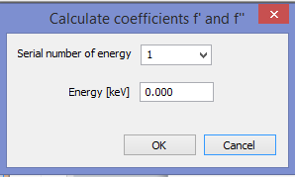

Edit->copy 3D to clipboard – this command copy the 3D scene to clipboard as a bitmap after that the clipboard content can be used in any program.

Edit->refresh – this command refreshes all windows

Fit- it is the main fitting dialog box

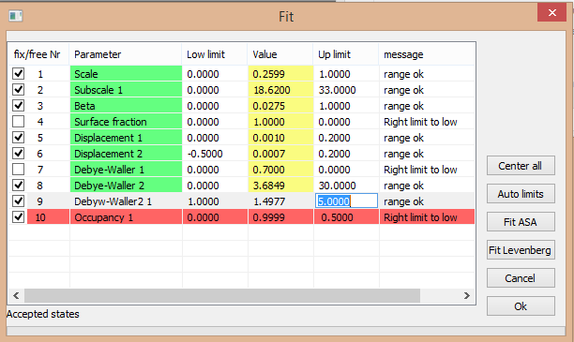

The cross boxes on the right, shows which parameters have to be fitted. Fitted parameters before fit start are checked for correct limits range. In case of any inconsistences the parameter is in red with appropriate comment 9like for occupancy on the image). For fast parameter range adjustment an option Auto limits is available. All parameters can be center with Center all button. From this dialog box two fitting methods are available ASA and Levenberg. ASA is for global optimization and Levenberg for fine tuning of the global minimum which is found by ASA. During fitting a bars presented fitting progress are show: number of accepted states, parameters values and they temperature.

--------------------------------------------------Calc menu-------------------------------------------------

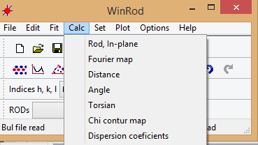

Rod, In-plane – dialog window for settings of Rod and in-plane calculations
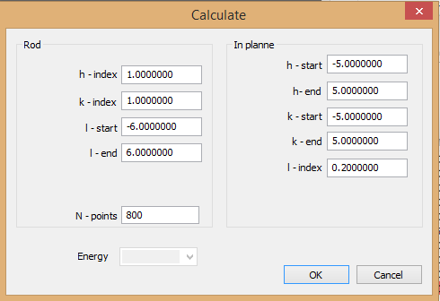

Calc -> Fourier map – dialog box for Fourier maps calculation. The result is presented in 2D contour window below.

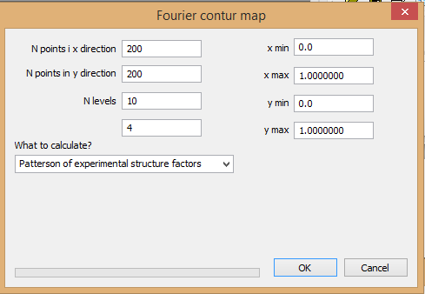

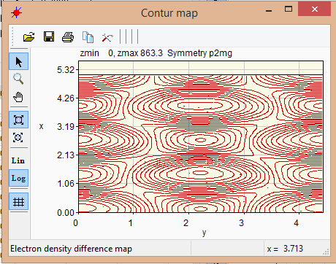

Calc- distance, Calc-angle, calc -> torsion – are for calculations in 3D window

Calc- chi contur map – calculate the contour map for chi² changes depending on two parameters. It can be useful in finding two close minima.

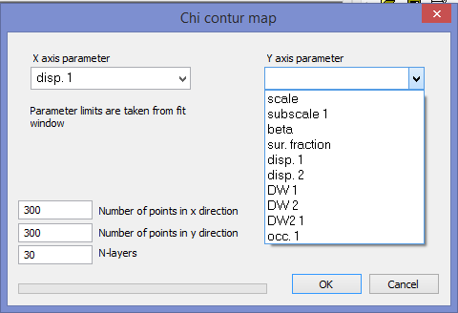

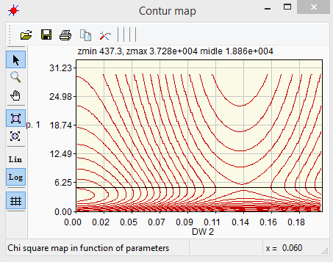

Calc -> dispersion parameters – dialog box to set all parameters for f’ and f” coefficients for given element.

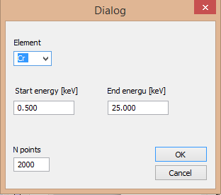

Results of coefficients f’ and f” calculations
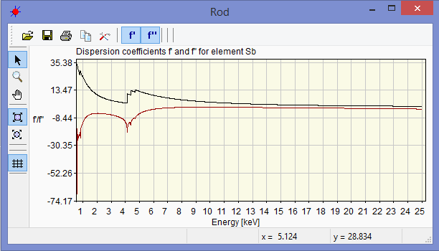

------------------------------------------------- Set menu ---------------------------------------------------

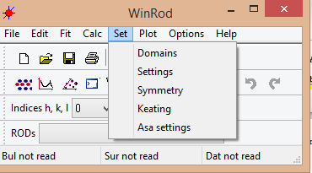

Set->domains - This dialog box allows domain settings like: occupancy, the domain rotation matrix and number of domains. It is possible to fit domains occupancy automatically, in such case the domain occupancy parameter is displayed in fitting dialog box as a parameter.

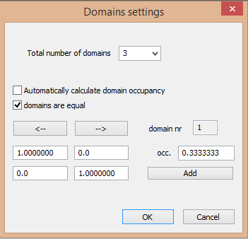

Set->settings - This dialog box sets standard parameters like surface fraction, beta model, sigma method calculation can be set. Additionally for ASA algorithm number of processor cores and thread priority can be selected. Nlayer 2 is a number of atoms in second surface unit cell.

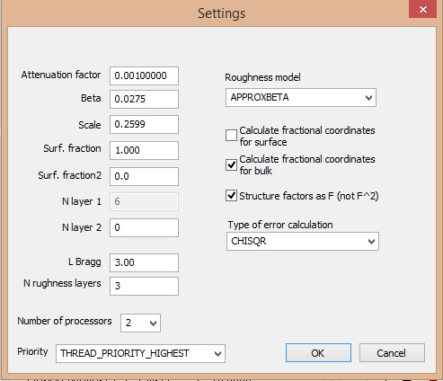
Set->symmetry group –This dialog box sets the surface symmetry for Fourier calculations

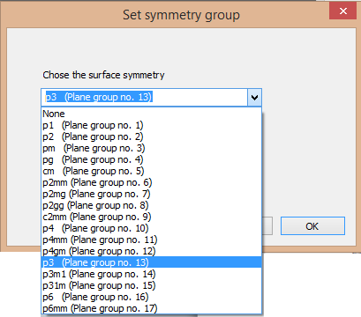

Set->ketting – This dialog box sets all parameters for ketting

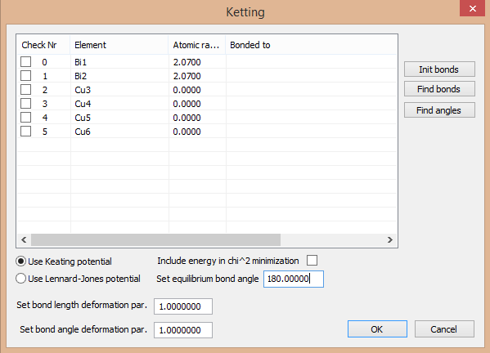

Set->ASA – This dialog box sets parameters for ASA optimization method

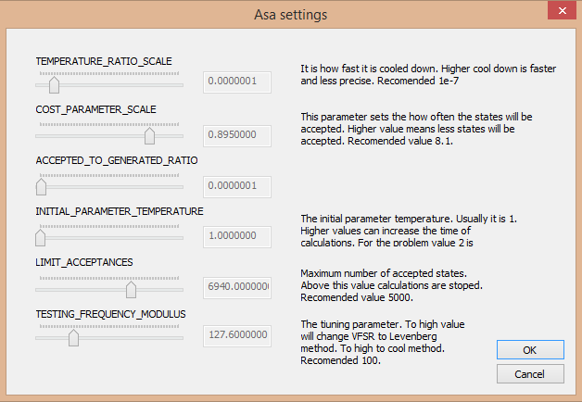

- Start new project

- Read all important files with extensions *.bul (bulk file), *.fit (fit file for surface modeling), *.dat file with experimental structure factors and *.par (file with parameters).
In examples directory you can find AgSb and 2012 directories with real data, the AgSb is more simple, has one domain and 2012 has three rotational domains.

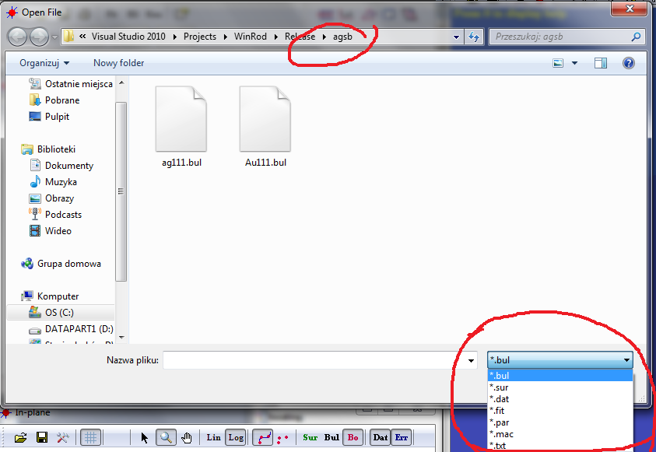

- When all important files are read the status bar will looks like below:

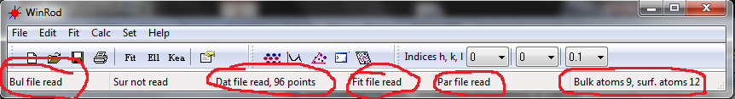

- After that you can edit the *.fit or *.bul files, add or remove atoms, add/remove or change parameters. The philosophy is the same like in Rod program. all the changes are directly presented in the 3D model window.

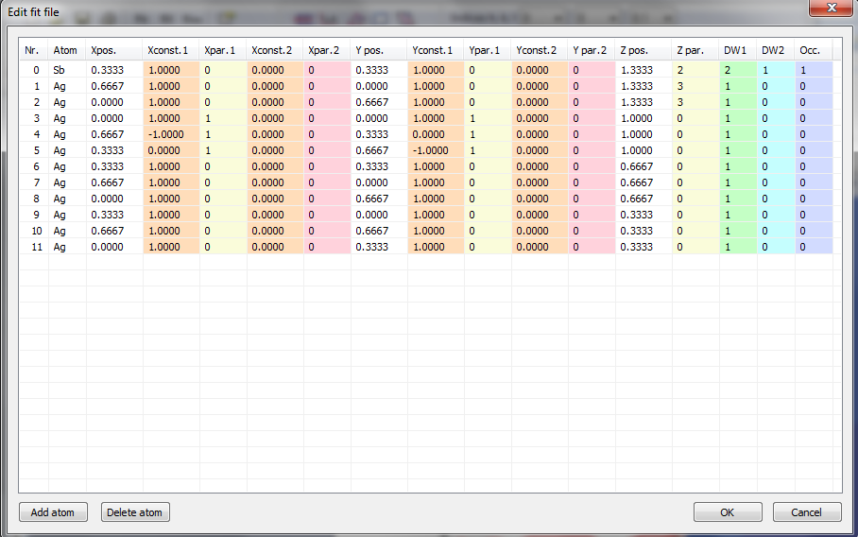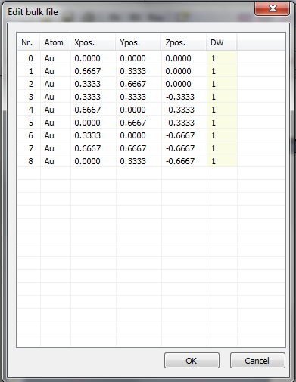
Fit file edit window Bul file edit window

- Fitting is very simple just remember about correct parameter range (not all tests are implemented at the moment and the program is still a bit sensitive to incorrect actions. In the toll bar chose fit after that a new window with fitting routine will appear. Chose the parameters you would like to fit, they starting value and range (after editing values press enter this mandatory prior to accept the change). If all changes are applied press Fit ASA or Fit Levenberg button. This will start the fitting procedure. In WinRod the fitting with ASA is divided on 4 threads (the number can be changed with time if necessary for modern processors) this greatly reduces the calculation time. The advanced processor commands SSE are used only by memory copy provided by Microsoft macros but in a future they can be implemented in Fourier transform what should increase the speed of factor 4.

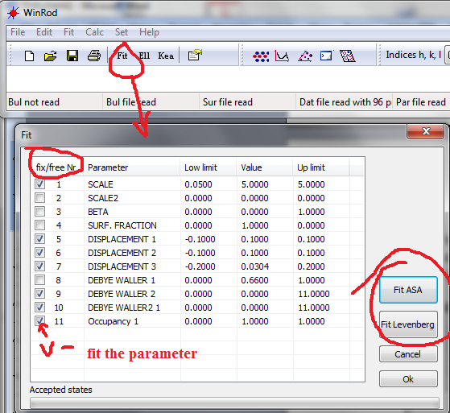

5) Fitting:

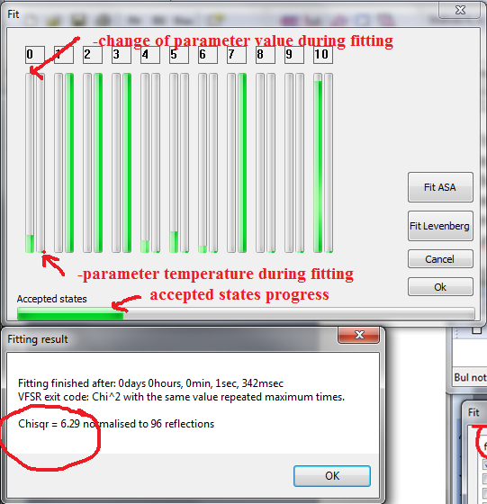

The final result and fitting time is presented in the new window. The χ value is normalized to all data points. Usually for simple problems it takes below 1s. The fitting ASA routine is now hardly optimized for surface diffraction analysis. This was done with specially prepared macros where all fitting parameters were tested in all combinations. After that about 1000 fits were analyzed for the best settings.

6) The 3D model Window can presents results in different ways:

-Standard view
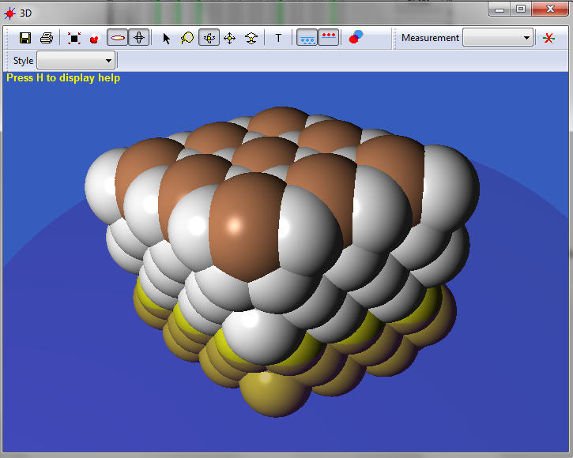

- The list of different styles can be chosen from the marked control. The styles can be mixed by using the select control (smaller ring) and then appropriate presentation style.
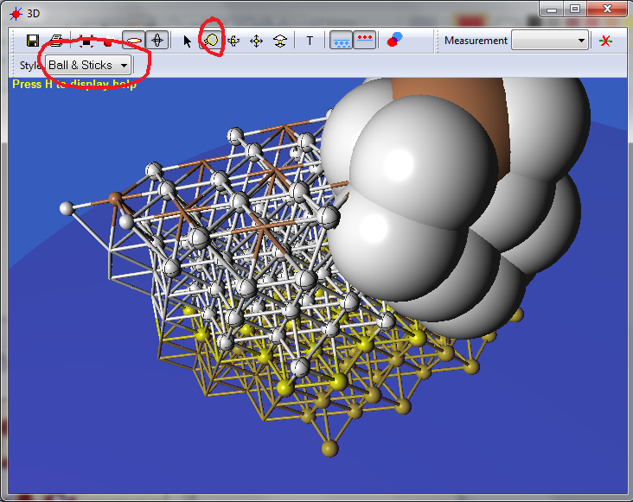

Measuring: you can measure distance, angle and torsion angle. First select all interesting atoms and chose the measurement. For distance select two points, for angle three for torsion four atoms.
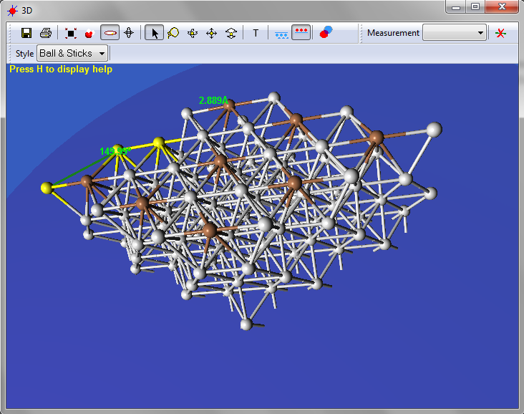

Comparison of the fitting to the previous fit or parameters set.
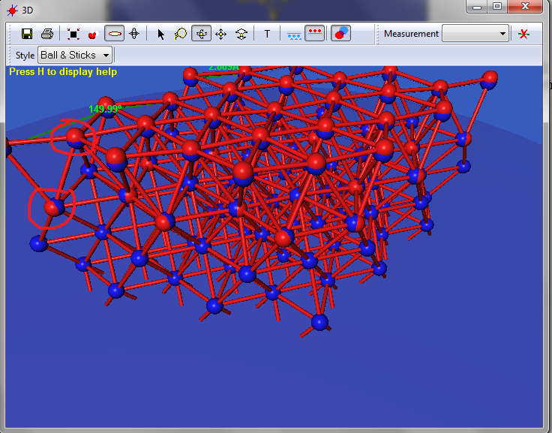

-Selected atoms can be deleted by spacebar (in this version).

7) Presentation:
-The fitting results are presented in 2D windows: Rod, In-plane and electron density profile in z direction. These windows are calculated directly after reading and fitting.

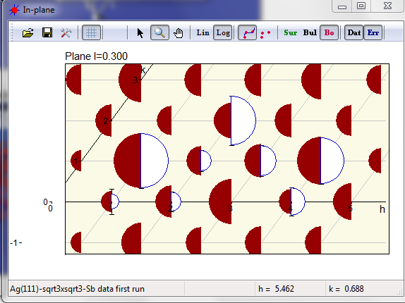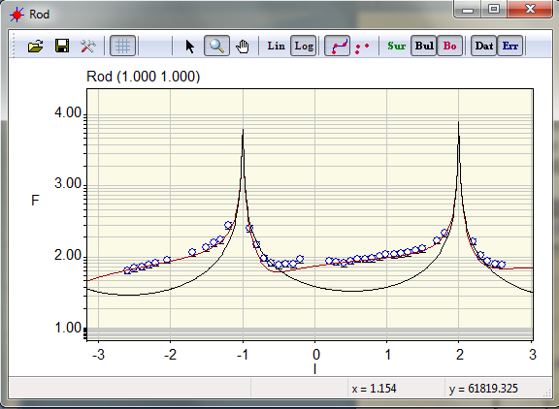

8) Saving and export the results:

-parameter, bulk and fit files can be exported from the main window, at the moment they are not implemented in command line window (the link is there but not fully implemented) and from macro file.

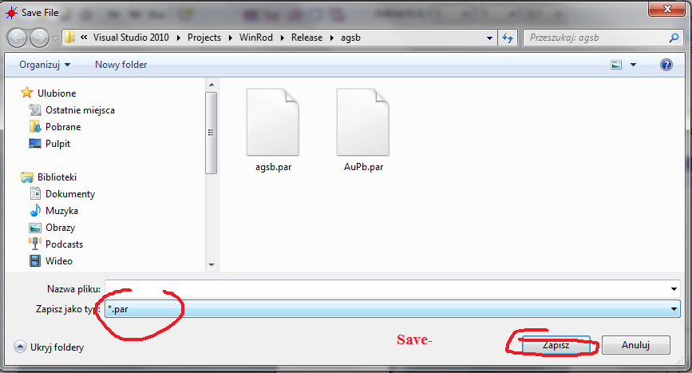

- 2D windows:
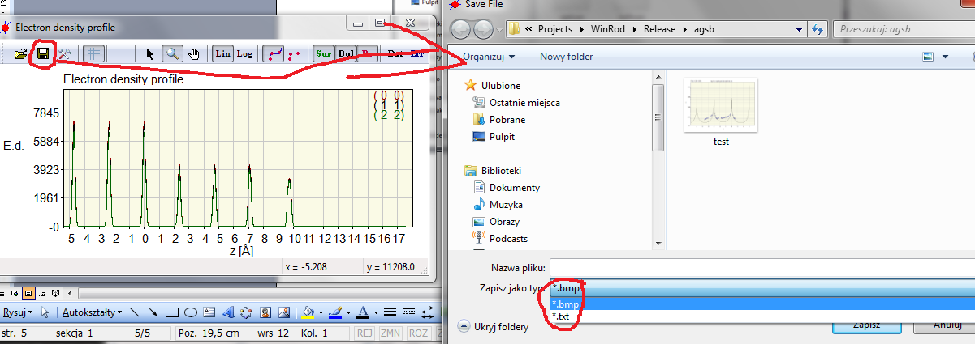
In this case the result can be saved as a bitmap or numerical text file with x,y,z columns.
In 2D windows it is possible to change the scale with track ball of the mouse, shifts the scale with the hand tool, zoom it with zoom tool. Pressing the right mouse button sets the most optimal scale calibration. The l range can be also changed from the calc\Rod, In-plane menu.

9) Fourier maps:
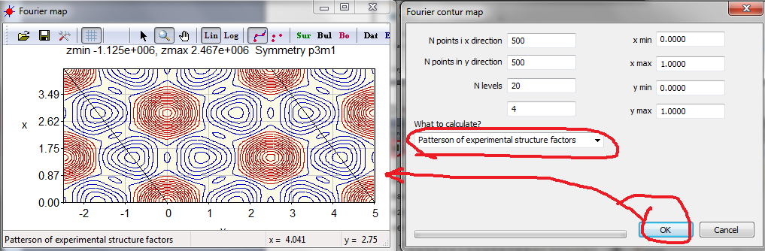

You have to select what kind of Fourier map to calculate, the x, y range of calculations, density of calculated points and number of layers. Also in this case it is possible to export numerical data to e.g. Orygin 8.6 and then from this program generate Fourier maps like the one below. The position on the map is shown in status bar on the window bottom.

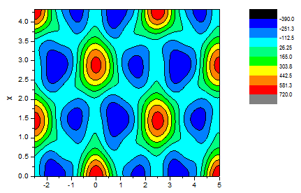

10) Command line:
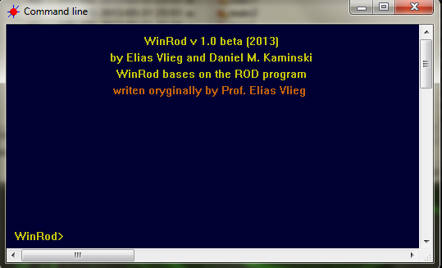
Only part of the original functions from Rod is now implemented in the command line. This are: ca (calculate), re – read, set and list.

ca -> ?, inp, rod
set ->list the parameters
list -> bul, sur
plot will is removed completely because is handled by the main program.

11) Macros

In WinRod you can use macros like this one. They can be read from the standard read window:
Example of the parameter file:

//Set the parameters
set
indexh 1
indexk 1
indexl 0.2

//Set the parameters for fit engine of ASA
TEMPERATURE_RATIO_SCALE 1.0E-6
TEMPERATURE_ANNEAL_SCALE 1000
COST_PARAMETER_SCALE 0.8
ACCEPTED_TO_GENERATED_RATIO 1.0E-11
INITIAL_PARAMETER_TEMPERATURE 10
DELTA_X 1.0E-7

//Read files
read fit agsb.fit
read bul ag111.bul
read dat agsb.dat

read par agsb.par

//Fit the data and repeat the fitting 50 times
fit loop 50
fit asa
fit run

